|  |  |
| --- | --- |
| *Pacific Gas and Electric Company* | |
| Release 9.7.5 Installation Guide | |
|  |  |
|  |  |
| Project | ED AM/GIS |
|  |  |
| Prepared by | Subhankar Baidya |
| Date | 9/18/2015 |
| Version | 1.0 |
| Version Type | Draft |

|  |  |  |  |
| --- | --- | --- | --- |
| Revision History | | | |
| Document # | Date | Author | Summary of Changes |
| 1.0 | 9/11/2015 | Subhankar Baidya | Initial Document Creation |
|  |  |  |  |

# Introduction

## Purpose

This document is intended to detail the implementation and configuration steps required to implement Release 9.7.5 Installation Guide. This document describes the various configuration aspects required to complete any manual or automatic patch associated with this release. Each section in this document contains the steps required to patch the system in production.

## Terms Used

|  |  |
| --- | --- |
| OOTB | Out of the box. Unmodified from the commercial version. |
| TFS | Team Foundation Server |

## External Documents

Referenced are any external configuration documents or exports. These are documents that contain more detailed information about configuring a system or documents that can be loaded into an application to perform the configuration detailed in this document.

1. Supporting documentation folder
   1. **TFS documentation location:**

$/EDAMGIS/Source_Development_10_2_1/Documentation/Data Model/Release Documentation/EDER/9.7.5

## List of Fixes

Below is the list of change requests detailing all fixes for the data model for this release:

|  |  |
| --- | --- |
| **Item Number** | **Title** |
| [23850](http://edappgistfsprd1:8080/tfs/ElectricDistCollection/EDAMGIS/_workitems/edit/23850) | Master TFS DM 9.7.5 |
| [23273](http://edappgistfsprd1:8080/tfs/ElectricDistCollection/EDAMGIS/_workitems/edit/23273) | PAR 112393: Missing codes/values for Dyn Protect Device Type Interrupter domain |
| [23709](http://edappgistfsprd1:8080/tfs/ElectricDistCollection/EDAMGIS/_workitems/edit/23709) | PARS 114148, 114158, 113115 Missing code/values from the Underground Switch Type Domains”. |
| [23431](http://edappgistfsprd1:8080/tfs/ElectricDistCollection/EDAMGIS/_workitems/edit/23431) | PAR 112954 – Identified "New" SWITCH table CC Rating value "630" |
| [23432](http://edappgistfsprd1:8080/tfs/ElectricDistCollection/EDAMGIS/_workitems/edit/23432) | PAR 110664: code/value not currently in the “ULS Size-coded value” domain |
| 23858 | Create EDGIS.SAP package in EDER Maintenance database |
| 24046 | Create Underground Network Trace tables |
| [24106](http://edappgistfsprd1:8080/tfs/ElectricDistCollection/EDAMGIS/_workitems#_a=edit&id=24106) | Update DUCTDEFINITION field properties |
| [24125](http://edappgistfsprd1:8080/tfs/ElectricDistCollection/EDAMGIS/_workitems#_a=edit&id=24125) | Remove PGE Anno Horizontal AU from Secondary Generation 50 Scale Anno |
| [21621](http://edappgistfsprd1:8080/tfs/ElectricDistCollection/EDAMGIS/_workitems#_a=edit&id=21621) | Change ULS Material domain description for Soapstones |
| [24203](http://edappgistfsprd1:8080/tfs/ElectricDistCollection/EDAMGIS/_workitems#_a=edit&id=24203) | Configure MISCIDC1 field on Duct feature class |

Contents

1 Introduction 3

1.1 Purpose 3

1.2 Terms Used 3

1.3 External Documents 3

1.4 List of Fixes 4

2 EDGIS 6

2.1 23273: PAR 112393: Missing codes/values for Dyn Protect Device Type Interrupter domain 6

2.2 23709: PARS 114148, 114158, 113115 Missing code/values from the Underground Switch Type Domains”. 7

2.3 23431: PAR 112954 – Identified "New" SWITCH table CC Rating value "630" 8

2.4 23432: PAR 110664: code/value not currently in the “ULS Size-coded value” domain 9

2.5 23858: Create EDGIS.SAP package in EDER Maintenance database 10

2.5.1 Prequisites 10

2.5.2 Steps 10

2.6 24046: Create Underground Network Trace tables 10

2.6.1 Steps 10

2.7 24106: Update DUCTDEFINITION Field Properties 11

2.8 24125: Remove PGE Anno Horizontal AU from Secondary Generation 50 scale 12

2.9 21621: Change ULS Material domain description for Soapstones 13

2.10 24203: Configure MISCIDC1 field on Duct feature class 14

2.11 Update Data Model Version Table 15

3 Known Issues 16

# EDGIS

## 23273: PAR 112393: Missing codes/values for Dyn Protect Device Type Interrupter domain

Add code/values to the domain: **Dyn Protect Device Type Interrupter**

**Code** **Description**

ISSI ISSI

GW G&W

EM Elastimold

1. Open ArcCatalog. Get exclusive access of EDGIS user.
2. Right Click on the root node. Select “Properties”.
3. Add code/values to the domain: Dyn Protect Device Type Interrupter.

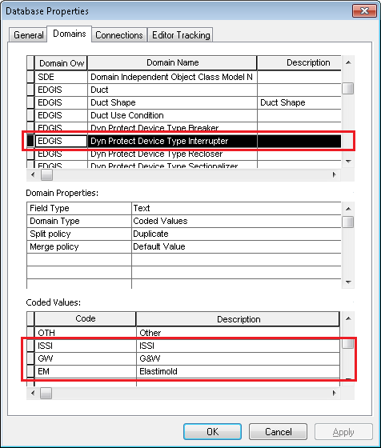

1. Click Apply. Click OK.

## 23709: PARS 114148, 114158, 113115 Missing code/values from the Underground Switch Type Domains”.

**Domain**: Underground Switch Type

Code Description

20 Vacuum in oil

1. Open ArcCatalog. Get exclusive access of EDGIS user.
2. Right Click on the root node. Select “Properties”.
3. Add code/values to the domain: Underground Switch Type.

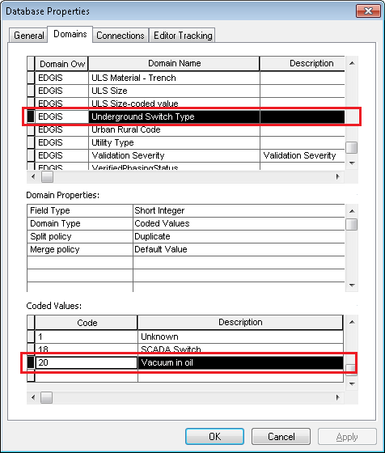

1. Click Apply. Click OK.

## 23431: PAR 112954 – Identified "New" SWITCH table CC Rating value "630"

Add new code/value to the **Rated Amps** domain:

Code Value

630 630A

1. Open ArcCatalog. Get exclusive access of EDGIS user.
2. Right Click on the root node. Select “Properties”.
3. Add code/values to the domain: Rated Amps.

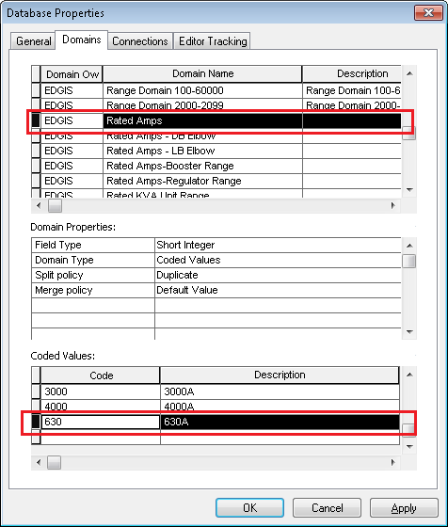

1. Click Apply. Click OK.

## 23432: PAR 110664: code/value not currently in the “ULS Size-coded value” domain

Add new code/value to the **ULS Size-coded value** domain:

Code Value

18 18”

1. Open ArcCatalog. Get exclusive access of EDGIS user.
2. Right Click on the root node. Select “Properties”.
3. Add code/values to the domain: ULS Size-coded value.

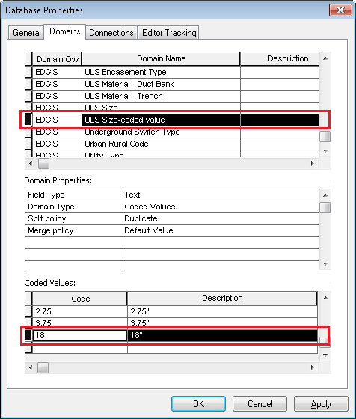

1. Click Apply. Click OK.

## 23858: Create EDGIS.SAP package in EDER Maintenance database

### Prequisites

[Change Request 22858:](http://edappgistfsprd1:8080/tfs/ElectricDistCollection/EDAMGIS/_workitems/edit/22858)Create PGEData schema/user in publication/batch database

This should be executed against publication for lower environments, batch database for Production

### Steps

1) Log into the target EDER maintenance database as edgis and paste in the following file:

$/EDAMGIS/Source_Development_10_2_1/Documentation/Data Model/Release Documentation/EDER/9.7.5/3_create_edgis_sap.sql

Ensure no errors occur.

## 24046: Create Underground Network Trace tables

### Steps

1) Log into the target EDER maintenance database as edgis and paste in the following file:

$/EDAMGIS/Source_Development_10_2_1/Documentation/Data Model/Release Documentation/EDER/9.7.5/create_underground_cached_tables.sql

Ignore the following errors if they occur:

- name is already used by an existing object

- table or view does not exist

## 24106: Update DUCTDEFINITION Field Properties

** If alredy implemented then ignore this CR.

1. Right-click on the DUCTDEFINITION table in the root dataset and select ArcFM Properties Manager
2. Select the Field Info tab
3. Select the Duct Bank subtype
4. Select the DUCTSHAPE field
5. Modify the Visible property to Yes and click Apply

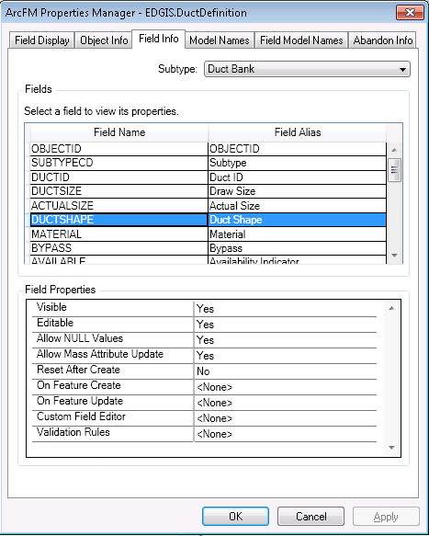

1. Select the BYPASS field
2. Modify the Visible property to Yes and click Apply
3. Select the CONDITION field
4. Modify the Visible property to Yes and click Apply
5. Select the MISCIDC1 field
6. Modify the Visible property to Yes and click Apply
7. Click OK to close the dialog

## 24125: Remove PGE Anno Horizontal AU from Secondary Generation 50 scale

1. Right-click on SecondaryGeneration50Anno and select ArcFM Properties Manager
2. Select the Object Info tab
3. In the On Feature Create event, remove the PGE Annotation Horizontal Alignment AU

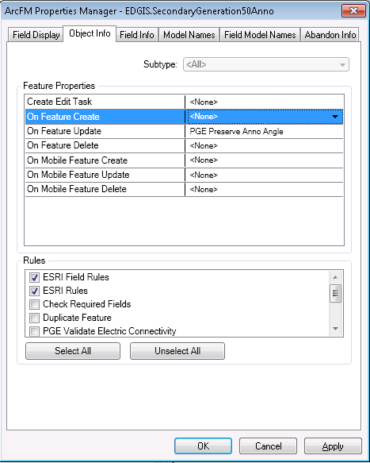

1. Click OK

## 21621: Change ULS Material domain description for Soapstones

1. Right click on the database level node and select Properties
2. Select the Domains tab
3. Select the "ULS Material- Duct Bank" domain
4. Select the SS, Soapstones domain entry
5. Update the description from Soapstones to "SS"

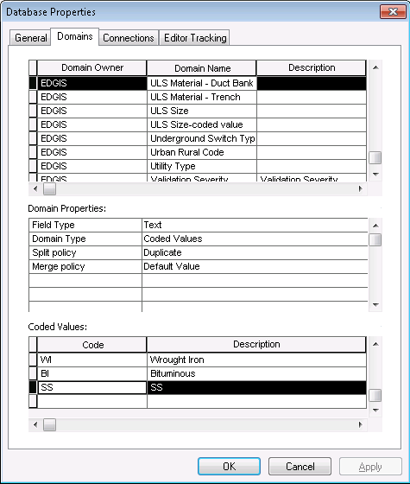

1. Click OK

## 24203: Configure MISCIDC1 field on Duct feature class

1. Right-click on the Duct feature class in the UFM dataset and select ArcFM Properties Manager
2. Select the Field Info tab
3. Select the MISCIDC1 field
4. Set the visible property to Yes

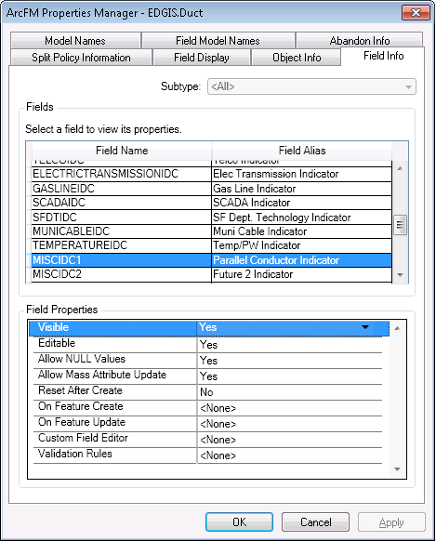

1. Click Apply
2. Select the Field Model Names tab
3. Select the MISCIDC1 field
4. Assign the PGE_DUCTSYNCATTR from the PGE ED Field Model Name domain

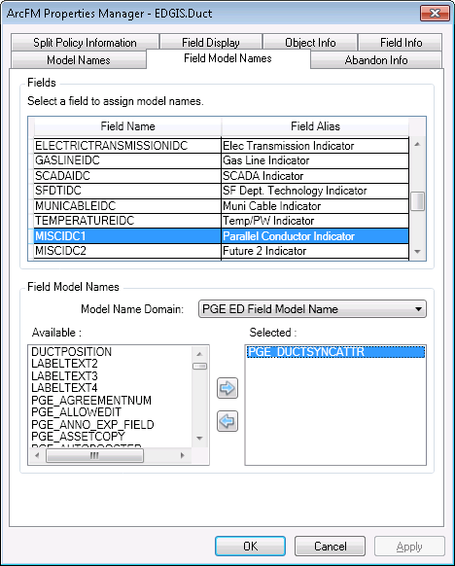

1. Click OK

## Update Data Model Version Table

**Database Configuration:**

1. Open SQL Plus.
2. Log in using the same server and user as was used in section 2.1.  
     
   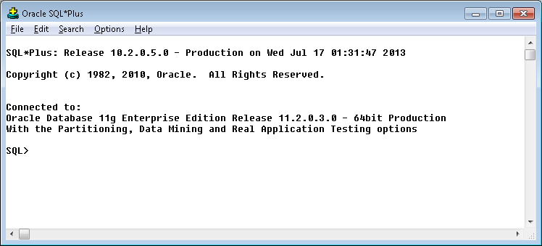
3. Run the SQL below:

update pgedatamodelversion set currentidc='N' where currentidc='Y';

insert into pgedatamodelversion (OBJECTID, CURRENTIDC, DATEAPPLIED, APPLIEDBYPERSONNAME, MODELVERSION) values (**SDE.VERSION_USER_DDL.NEXT_ROW_ID('EDGIS',(select registration_id from sde.table_registry where table_name='PGEDATAMODELVERSION'))**,'Y',sysdate,'**Philip Penn**','**9.7.5** GOLD');

commit;

# Known Issues

<Please List any other issues encountered here while following the document>